Mise-en-Scène

What is Mise-en-Scène?
- A French term meaning what is put into a scene or frame
- Visual information in front of the camera
- Communicates essential information to the audience
- made up of various elements

Elements of Mise-en-Scène?
- Settings & Props
- Costume, Hair & Make Up
- Facial Expressions & Body Language
- Lighting and Colour
- Positioning of characters/objects within the frame

The following research activities will help familiarise you with the concept and develop image interpretational and analytical skills.

Consider the questions below to provide a framework for your blog and a brief summary of what you have learnt.

Research Activity 1

Can you describe how the elements of Mise-en-Scène in the following scene?

Watch the following scene

- Snow White (Disney Studios,1937)
- https://www.youtube.com/watch?v=cB7O_JIxGuY

- Settings & Props
The forest setting is highly stylised and exaggerated, transforming a natural environment into a threatening psychological space. Twisted trees and sharp shapes visually reflect Snow White’s fear, turning the setting into an extension of her emotional state rather than a realistic location.
- Costume, Hair & Make Up
Snow White’s bright dress contrasts strongly with the dark forest. Her soft colours and clean design emphasise innocence and vulnerability against the hostile environment.
- Facial Expressions & Body Language
Snow White’s wide eyes, frantic movements, and defensive gestures communicate fear and panic. Her body language is exaggerated in a way that suits animation, making her emotional state immediately legible.
- Lighting and Colour
Low-key lighting dominates the scene, with deep shadows and high contrast. Dark blues, greens, and blacks overwhelm the frame, reinforcing danger and disorientation.
- Positioning of characters/objects within the frame
Snow White is often framed centrally but overwhelmed by the surrounding environment, visually suggesting her powerlessness.
- What role does the shot choice (Cinematography) play in the scene.
Dynamic camera movement, close-ups, and extreme angles heighten tension. The shifting perspectives make the forest feel alive and threatening, intensifying the emotional impact of the scene.

Research Activity 2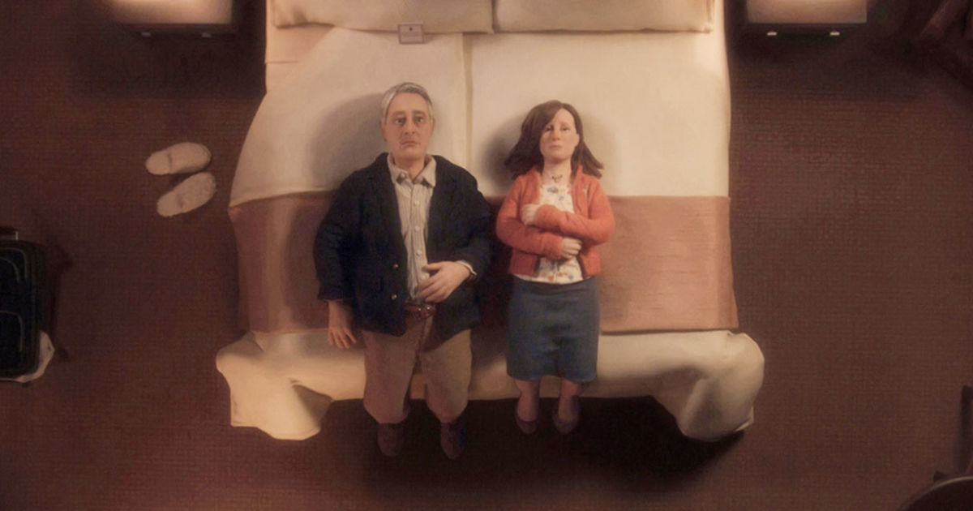
Anomalisa. Charlie Kaufman 2016
Can you describe the mise-en-scene in this picture? How are the characters placed in the frame?
The mise-en-scène in Anomalisa is deliberately restrained and minimal. Characters are often placed symmetrically within the frame, reinforcing themes of emotional isolation and monotony. The hotel setting is bland and repetitive, reflecting the protagonist’s sense of alienation.
The neutral colour palette and soft, even lighting create a sense of emotional flatness. Characters are frequently positioned with physical distance between them, even during conversations, visually expressing disconnection and discomfort. The controlled, static framing supports the film’s exploration of identity and intimacy.

Research Activity 3

Watch this scene from Rebecca.
https://www.youtube.com/watch?v=h23zAV2Wnps
(36mins into the film)

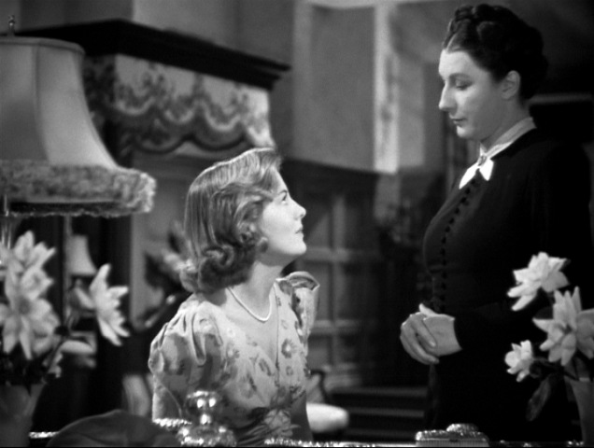
Rebecca (Hitchcock.1940)

Can you describe the relationship between the characters?
The relationship between the characters is defined by power imbalance and psychological tension.

How do we know what the relationship is?
We understand the relationship through visual cues rather than dialogue alone. Differences in posture, framing, and spatial dominance indicate control and vulnerability.

Can you describe how the mise-en-scene works together to tell us what the relationship is?
Lighting, costume, and positioning work together to express hierarchy. One character is often placed in a dominant position within the frame, while the other is visually diminished through distance, shadow, or lower placement. The setting itself feels imposing, reinforcing emotional oppression.

High Key Lighting
Low Key Lighting

Natural Lighting

High Angle Shot

Low Angle Shot

Can you describe the mise-en-scene in this picture? The scene is set in a crowded urban street or marketplace, where buildings are densely packed, the streets are narrow, and overhead wires crisscross the space. The background is filled with numerous figures who lack distinct individual features. This environment creates a disordered social space, suggesting that the character exists within a social structure defined by restriction, instability, and insecurity.

What type of shot is it? Medium shot.
What is the camera angle? High-angle shot
Where is the character located in the frame? Positioned slightly off-centre, creating visual imbalance and unease.
What is she wearing? The character wears muted clothing, and lack of power.
What is the depth-of-field? Shallow depth of field isolates the character from the background, directing attention to her emotional state.
Describe the colour palette?
Describe the lighting?

WhWhat

W

